**PROJECT DOCUMENTATION AND REPORT**

**LONG TERM INTERNSHIP ON SALESFORCE**

PROJECT TITLE: VEHICLE MANAGEMENT SYSTEM

INDUSTRY MENTOR: 1. MOHAMMAD SAQUIB NADEEM

2. SHIVAM UPADHYE

FACULTY MENTOR: K.L.V.NAGASREE

TEAM SIZE: 4

TEAM LEADER: D.TULASI

TEAM MEMBERS: 1. B. SAI SPANDANA

2. B. GAYATHRI

3. N. TARUNI

1. **INTRODUCTION**

**PROJECT DECRIPTION:**

Vehicle Management is an application where a customer Details are stored in order to choose cars, bikes and commercial vehicles for travel within the city. The data which is stored here, further used to remind them if any offers are provided during the seasons and any updates regarding vehicles are sent to them in the form of messages and mails.

**SALESFORCE:**

Salesforce is your customer success platform, designed to help you sell, service, market, analyse, and connect with your customers.

Salesforce has everything you need to run your business from anywhere. Using standard products and features, you can manage relationships with prospects and customers, collaborate and engage with employees and partners, and store your data securely in the cloud.

So what does that really mean? Well, before Salesforce, your contacts, emails, follow-up tasks, and prospective deals might have been organized something like this:

https://youtu.be/r9EX3IGdesk

1.1OVERVIEW

Every organization, whether big or small, has challenges to overcome and managing the information of Driver, Vehicle, Maintanance, Vehicle Type, and Fuel. Every Vehicle Management System has different Vehicle needs; therefore we design exclusive employee management systems that are adapted to your managerial requirements.

This is designed to assist in strategic planning, and will help you ensure that your organization is equipped with the right level of information and details for your future goals. Also, for those busy executive who are always on the go, our systems come with remote access features, which will allow you to manage your workforce anytime, at all times. These systems will ultimately allow you to better manage resources.

Case Study: XYZ Company's Vehicle Management Transformation with Salesforce Developer

* XYZ Company, a transportation company, implemented Salesforce Developer for its vehicle management processes.
* By utilizing Salesforce Developer, XYZ Company improved visibility into its vehicle inventory, reduced maintenance downtime, and optimized routes.
* Telematics data provided real-time insights into vehicleOP • The integration of GPS tracking systems and locations and driver behavior, leading to improved efficiency and cost control.
  1. PURPOSE:

The purpose of this application is to keep the record of text in the editor properly and the different text which is issues to the activities. The availability of content can be easily managed and text having different system of library.

The Vehicle Management System (VMS) is an application for the Automotive industry. It supports, in the area of Sales & Services, the business processes that you require as vehicle importer when dealing with your original equipment manufacturers (OEMs) and your dealers in new and used vehicle sales.

Vehicle Management System, as described above, can lead to error free, secure, reliable and fast management system. It can assist the user to concentrate on their other activities rather to concentrate on the record keeping. Thus it will help organization in better utilization of resources. The organization can maintain computerized records without redundant entries. That means that one need not be distracted by information that is not relevant, while being able to reach the information.

The aim is to automate its existing manual system by the help of computerized equipment and full-fledged computer software, fulfilling their requirements, so that their valuable data/information can be stored for a longer period with easy accessing and manipulation of the same. Basically the project describes how to manage for good performance and better services for the clients.

1. **LITERATURE SURVEY**

It may help collecting perfect management in details. In a very short time, the collection will be obvious, simple and sensible. It will help a person to know the management of passed year perfectly and vividly. It also helps in current all works relative to Vehicle Management System. It will be also reduced the cost of collecting the management & collection procedure will go on smoothly.

Our project aims at Business process automation, Le. We have tried to computerize various processes of Vehicle Management System.

* In computer system the person has to fill the various forms & number of copies of the forms can be easily generated at a time.
* In computer system, it is not necessary to create the manifest but we can directly print it, which saves our time.
* To assist the staff in capturing the effort spent on their respective working areas.
* To utilize resources in an efficient manner by increasing their productivity through automation.
* It satisfies the user requirement.
* Be easy to understand by the user and operator.
* Be easy to operate.
* Have a good user interface.
* Be expandable

2.1 EXISTING PROBLEM:

In the existing system the exams are done only manually but in proposed system we have to computerize the exams using this application.

* Lack of security of data.
* More man power.
* Time consuming.
* Consumes large volume of pare work.
* Needs manual calculations.
* No direct role for the higher officials.

2.2 PROPOSED SOLLUTION:

The aim of proposed system is to develop a system of improved facilities. The proposed system can overcome all the limitations of the existing system. The system provides proper security and reduces the manual work.

* Security of data.
* Ensure data accuracy's.
* Proper control of the higher officials.
* Minimum time needed for the various processing.
* Greater efficiency.
* Better service.

**3 THEORITICAL ANALYSIS:**

DIAGRAMATIC OVERVIEW: Activity flow diagram for User

**VEHICLE NAME**

**ENTER EMAIL & PASSWORD**

**SEARCH**

SEA

SEARCH

**YES NO**

**ERROR**

**LOGOUT**

**REPORT**

**VEHICLE ROUTE**

HARDWARE REQUIREMENTS:

The old manual system was suffering from a series of drawbacks. Since whole of the system was to be maintained with hands the process of keeping, maintaining and retrieving the information was very tedious and lengthy.

The records were never used to be in a systematic order. There used to be lots of difficulties in associating any particular transaction with a particular context. If any information was to be found it was required to go through the different registers, documents there would never exist anything like report generation.

There would always be unnecessary consumption of time while entering records and retrieving records. One more problem was that it was very difficult to find errors while entering the records. Once the records were entered it was very difficult to update these records.

The reason behind it is that there is lot of information to be maintained and have to be kept in mind while running the business For this reason we have provided features Present system is partially automated (computerized), actually existing system is quite laborious as one has to enter same information at three different places.

SOFTWARE REQUIREMENTS:

The system must be interactive and the delays involved must be less so in every action-response of the system, there are no immediate delays. In case of opening windows forms, of popping error messages and saving the settings or sessions there is delay much below 2 seconds, In case of opening databases, sorting questions and evaluation there are no delays and the operation is performed in less than 2 seconds for opening sorting, computing, posting > 95% of the files. Also when connecting to the server the delay is based editing on the distance of the 2 systems and the configuration between them so there is high probability that there will be or not a successful connection in less than 20 seconds for sake of good communication

**Safety:** Information transmission should be securely transmitted to server without any changes in information

**Reliability:** As the system provides the right tools for discussion, problem solving it must be made sure that the system is reliable in its operations and for securing the sensitive details.

**Availability:** If the internet service gets disrupted while sending information to the server, the information can be sending again for verification.

**Security:** The main security concern is for users account hence proper login mechanism should be used to avoid hacking. The tablet id registration is way to spam check for increasing the security. Hence, security is provided from unwanted use of recognition software.

1. **RESULT:**

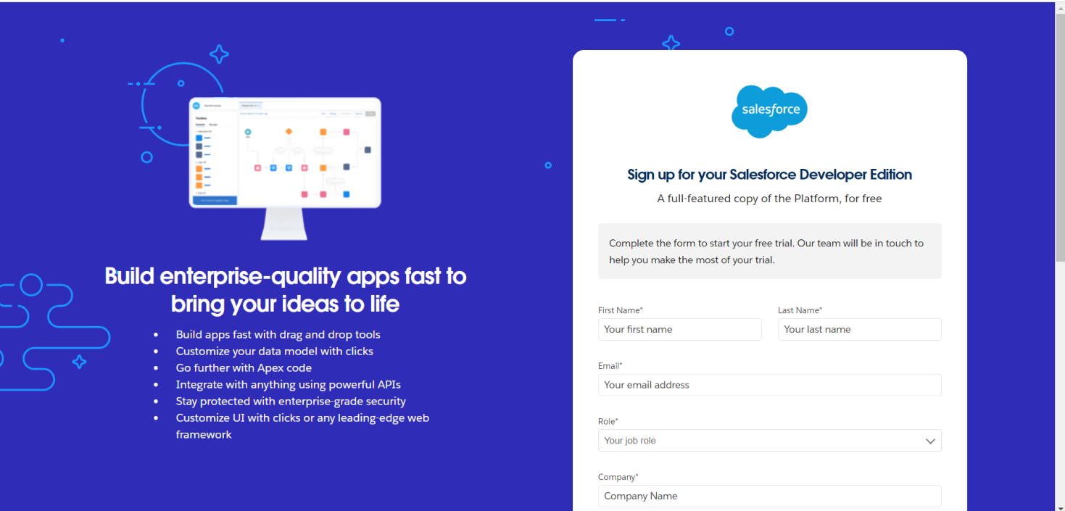

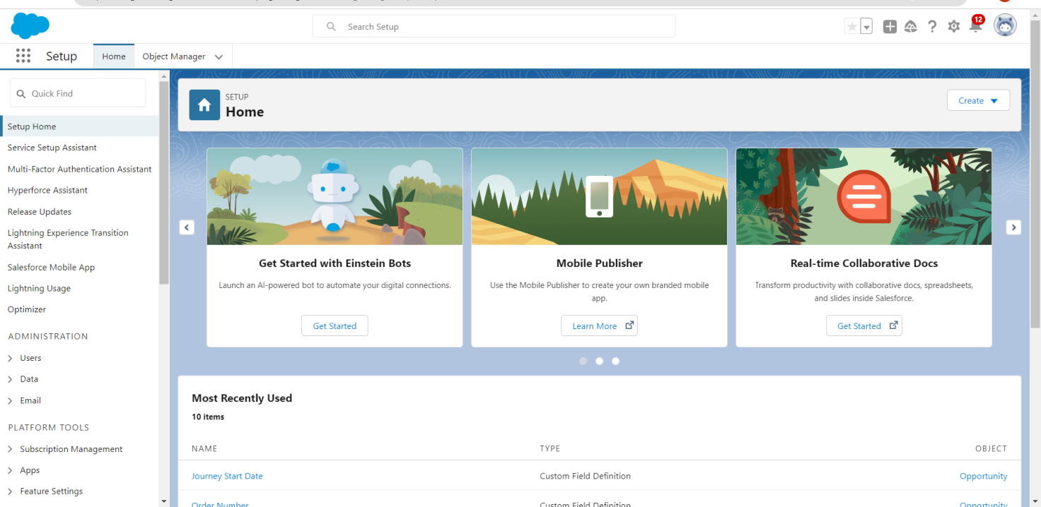

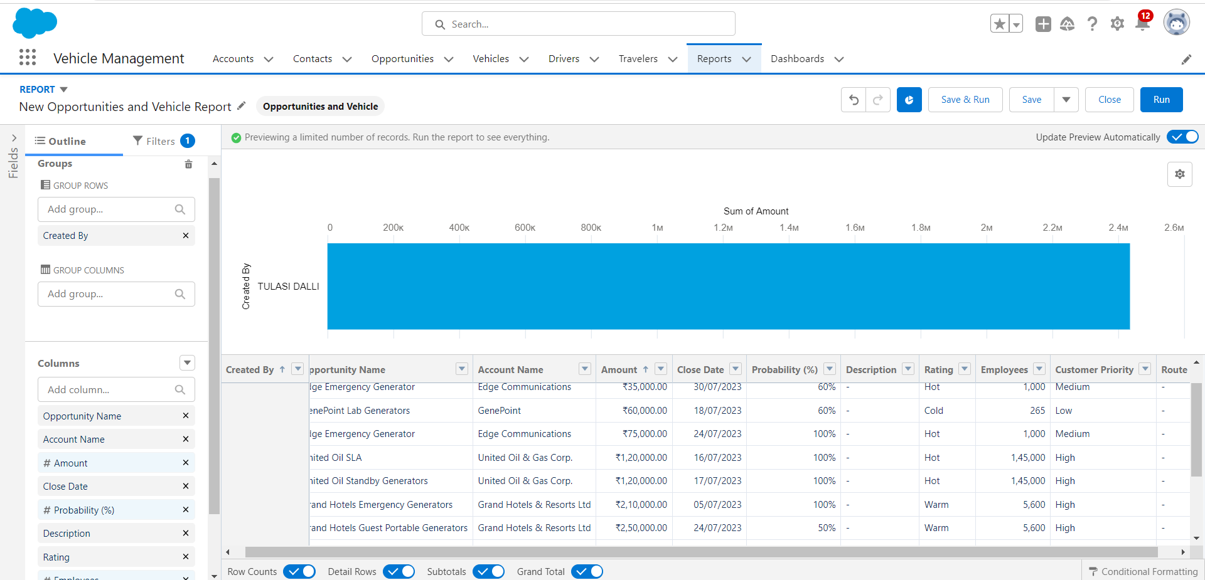

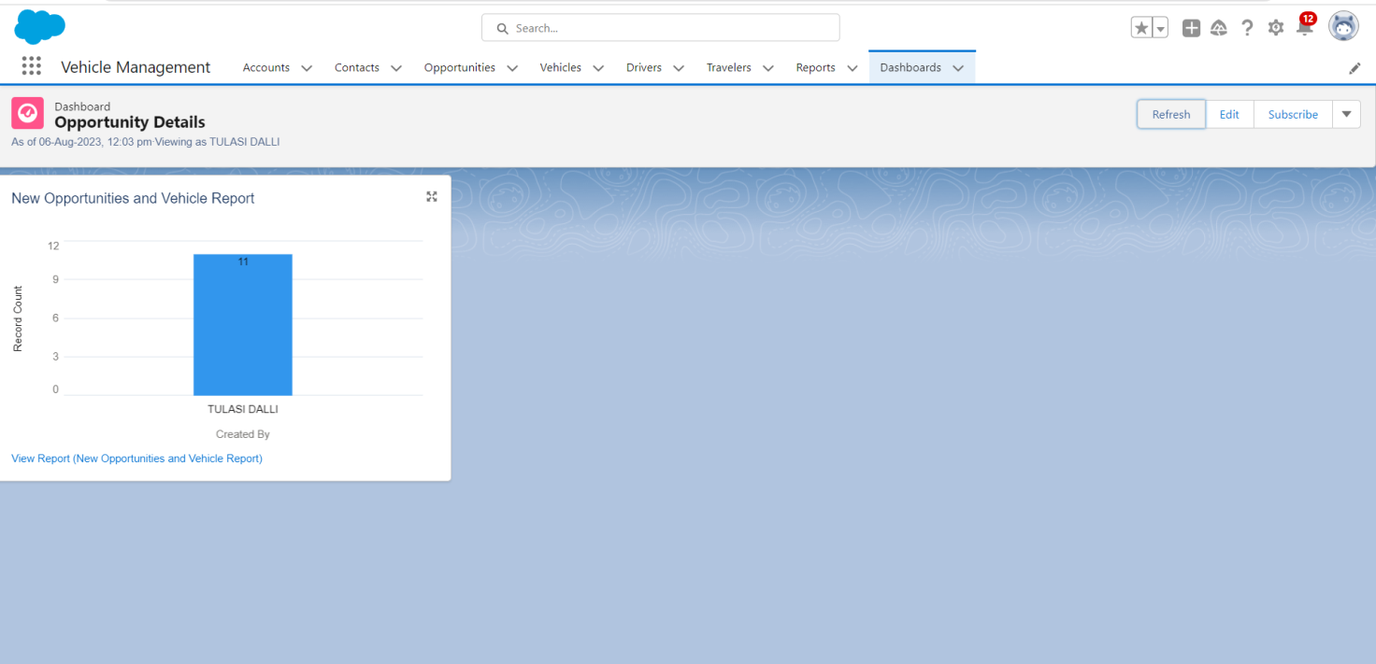

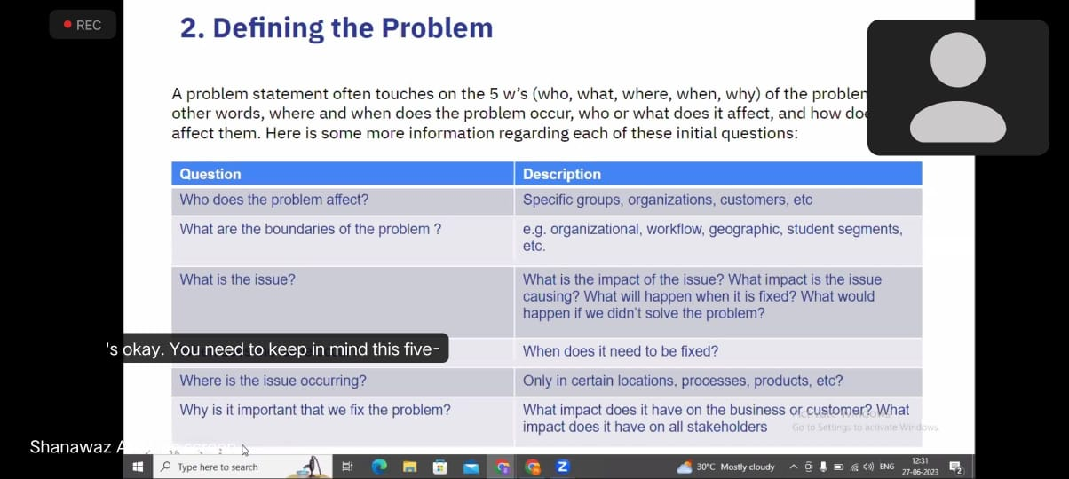

ATTENDING ONLINE CLASES

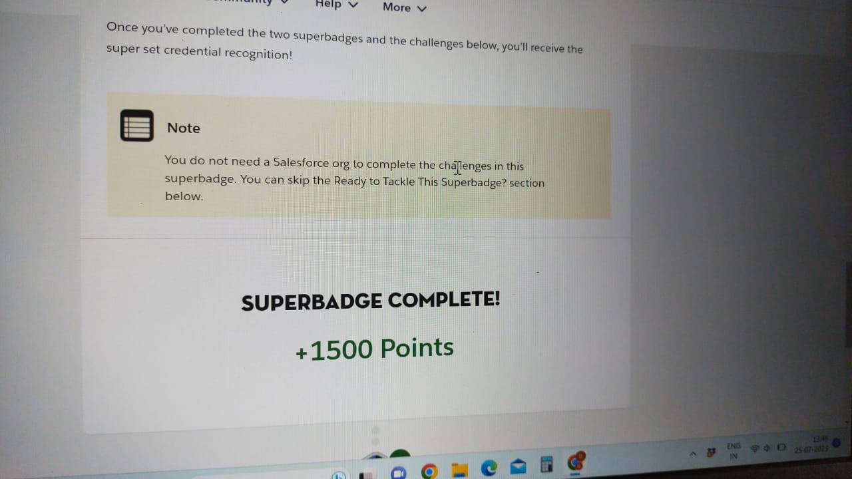

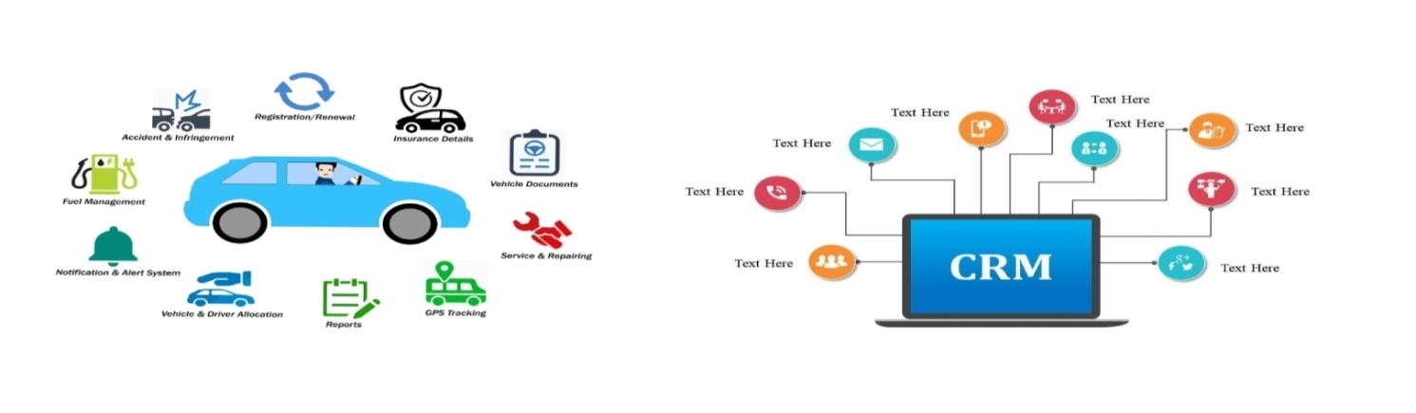

**ADVANTAGES:**

* Duplication of the Vehicle data is avoided.
* As Vehicle number is already stored in the master therefore human mistakes can be avoided.
* Timely alerts ensure that penalties are avoided.
* Vehicle Tracking and GPS Integration with Salesforce Developer.

**Improved visibility:** Salesforce Developer allows organizations to have a centralized view of their entire vehicle inventory, including details such as location, status, and usage.

**Enhanced maintenance scheduling:** With Salesforce Developer, maintenance schedules can be easily created and tracked, ensuring that vehicles are serviced on time and reducing downtime.

**Better cost control:**

Salesforce Developer enables organizations to accurately track vehicle expenses, including fuel usage, repairs, and maintenance, allowing for better cost control and budgeting.

**Safety:**

* Video recording for evidence.
* Accidents prevent and detect.
* Alarms detect.

**Save energy:**

* Route analyse.
* Driver behaviour analyse.

DISADVANTAGES:

There is a great possibility that agents incur a lot of money from poor people without their knowledge of actual expenditure as people have less information reach in the manual system.

Sometimes it is the spelling error in the manual system that gets saved and after that, while we check it in the final phase it gets rejected.

1. It is difficult to track the occupancy.

2. More manual hours need to generate required reports.

3. It is tedious to track the details of cabs provided by third party.

4. There is no possibility to track the approvals of requests.

5. No co-ordination between various departments.

6. It’s a time-consuming process.

7. Vulnerable storage of documents.

8. Maybe out-dated information gets passed.

**6 APPLICATIONS:**

The Software Requirements Specification is produced at the culmination of the analysis task. The function and performance allocated to software as part of system engineering are refined by establishing a complete information description, a detailed functional and behavioural description, an indication of performance requirements and design constraints, appropriate validation criteria, and other data pertinent to requirements.

* Vehicle Master captures all the information related to vehicles number, controlling location.
* One-stop information of vehicles includes engine number, registration number RC book number.
* It also has capability to store information of statutory documents like trance road tax, user can also upload scan copy of the documents.
* Salesforce Developer can be integrated with GPS tracking systems, allowing real-time tracking of vehicle locations and routes.
* Vehicle tracking data can be automatically captured and stored within Salesforoce Developer, providing up-to-date information on vehicle movements.

**7 CONCLUSION:**

THE VEHICLE MANAGEMENT SYSTEM PROPOSED TO MAKE EASY PROCESS OF MANAGING VEHICLE WITH THE OBJECTIVE TO REPLACE THE CURRENT APPROACH.

Our project is only a humble venture to satisfy the needs to manage their project work. Several user friendly coding have also adopted. This package shall prove to be a powerful package in satisfying all the requirements of the school.

The objective of software planning is to provide a frame work that enables the manger to make reasonable estimates made within a limited time frame at the beginning of the software project and should be updated regularly as the project progresses.

* A description of the background and context of the project and its relation to work already done in the area.
* We describe the requirement Specifications of the system and the actions that can be done on these things.
* We understand the problem domain and produce a model of the system, which describes operations that can be performed on the system.
* We included features and operations in detail, including screen layouts.
* We designed user interface and security issues related to system.
* Finally the system is implemented and tested according to test cases.

**FUTURE SCOPE:**

In a nutshell, it can be summarized that the future scope of the project circles around maintaining information regarding:

* We can add printer in future.
* We can give more advance software for Vehicle Management System including more facilities.
* We will host the platform on online servers to make it accessible worldwide.
* Integrate multiple load balancers to distribute the loads of the system.
* Create the master and slave database structure to reduce the overload of the database queries.
* Implement the backup mechanism for taking backup of codebase and database on regular basis on different servers

The above mentioned points are the enhancements which can be done to increase the applicability and usage of this project. Here we can maintain the records of Vehicle and Driver. Also, as it can be seen that now-a-days the players are versatile, i.e. so there is a scope for introducing a method to maintain the Vehicle Management System. Enhancements can be done to maintain all the Vehicle, Driver, Insurance, Maintenance and Fuel.

We have left all the options open so that if there is any other future requirement in the system by the user for the enhancement of the system then it is possible to implement them. In the last we would like to thanks all the persons involved in the development of the system directly or indirectly. We hope that the project will serve its purpose for which it is develop there by underlining success of process.

**REFERENCES:**

* Google for problem solving.
* <http://www.PHPworld.com/PHPworld/jw-01-1998/jw-01-Credentialreview.html>
* Database Programming with JDBC and PHP by O'Reilly
* Head First PHP 2nd Edition
* <http://www.jdbc-tutorial.com/>
* PHP and Software Design Concepts by Apress
* <https://www.tutorialspoint.com/PHP/>
* <http://www.PHPtpoint.com/PHP-tutorial>
* <https://docs.oracle.com/PHPse/tutorial/>
* <http://www.wampserver.com/en/>
* <http://wwhttp://www.tutorialspoint.com/mysql/>
* httpd.apache.org/docs/2.0/misc./tutorials.html

**THANK YOU**